|  |  |  |  |  |  |  |  |  |  |  |
| --- | --- | --- | --- | --- | --- | --- | --- | --- | --- | --- |
| Whitireia Logo_2010   |  | | --- | | **GROUP COVER FORM** |   **Report on Project Management**  **PROGRAMME: Project Management in Information Technology**  **COURSE CODE: IT7x25**  **ASSIGNMENT NUMBER: 3**  **TUTOR: MRS PREMLATHA SAMPATH**  **DATE OF SUBMISSION:**  **DUE DATE:**   |  |  | | --- | --- | | **STUDENT ID** | **NAME** | | **21901423** | **Vibha Chugh** | | **21900847** | **Joan Dias** | | **21900130** | **Mandeep Kaur** |  |  | | --- | | **We Certify that this is the team’s own Work:**  **Student Signatures: Vibha, Joan, Mandeep** | |

**Group Contribution Form**

The purpose of this form is to indicate to the lecturer the contribution each student has made to the overall assignment. It is completed by all group members at a meeting they must arrange on or before the due date.

Course Code: **IT7x25** Semester/Year: **2/2019**

Assignment Number: **3**

|  |  |  |  |  |
| --- | --- | --- | --- | --- |
| **Student Names** | **Student IDs** | **Percentage contribution to the assessment** | **Tasks worked on** | **Signature** |
| **Vibha Chugh** | **21901423** | **33.33%** |  |  |
| **Joan Dias** | **21900847** | **33.33%** |  |  |
| **Mandeep Kaur** | **21900130** | **33.33%** |  |  |
| **Total** |  | **100%** |  |  |

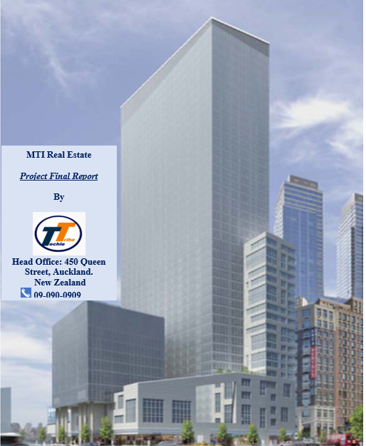

# Executive Summary

Table of Contents

[Executive Summary 4](#_Toc22552272)

[1.Feasibility Analysis 6](#_Toc22552273)

[1.1Overview 6](#_Toc22552274)

[1.2. Technical feasibility 6](#_Toc22552275)

[1.3. Financial feasibility 6](#_Toc22552276)

[1.3.1. Cost/Benefit Analysis 6](#_Toc22552277)

[1.3.2. Net Present Value 7](#_Toc22552278)

[1.3.3. Payback period 7](#_Toc22552279)

[1.4. Legal & Contractual feasibility 7](#_Toc22552280)

[1.5. Operational feasibility 8](#_Toc22552281)

[2. Methodology Selection & Implementation 8](#_Toc22552282)

[2.1. Scrum Methodology 9](#_Toc22552283)

[3.Discussion 11](#_Toc22552284)

[4.Summary 11](#_Toc22552285)

[7. Appendix 11](#_Toc22552286)

# 1.Feasibility Analysis

# 1.1Overview

# 1.2. Technical feasibility

|  |  |  |  |
| --- | --- | --- | --- |
| **Size / Complex** | **Low** | **Medium** | **High** |
| **Small** | Banner Area |  | Database, |
| **Medium** |  | Dashboard | ERP system, |
| **Large** | Load Data | finalise cloud service provider | Integrate security System, web page design |

Figure 1: Task Evaluation

# 1.3. Financial feasibility

# 1.3.1. Cost/Benefit Analysis

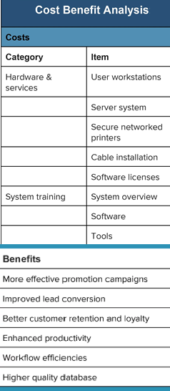

Figure: Cost Benefit Analysis

# 1.3.2. Net Present Value

# 1.3.3. Payback period

# 1.4. Legal & Contractual feasibility

1.4.1. Executing Smart Contract

1.4.2. Web Application compliance

# 1.5. Operational feasibility

1.6. EnvironmentalFeasibility

# 2. Methodology Selection & Implementation

.

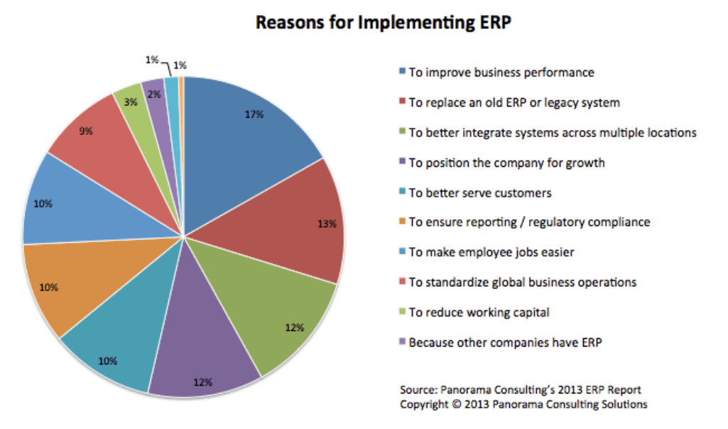

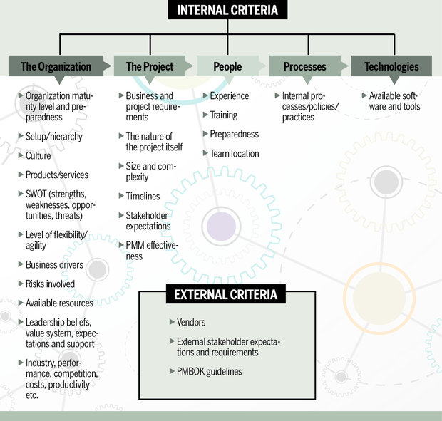

Figure: list of project methodology assessment criteria

# 2.1. Scrum Methodology

2.1.1 Tool/Software for Project Implementation Plan

2.1.1.2 Azure DevOps

2.1.1.1 Project Plan

2.1.1.2. Product Backlog

2.1.1.3. Active Sprints

2.1.1.4. Report

2.1.1.4.1 Sprint Report

2.1.1.4.2 Burndown Chart

2.1.1.4.3 User stories

2.1.1.4.5 Issues

2.2 MTI ERP system

2.2.1. Home Page

2.2.2. Login Page

2.2.3. Category Page

2.2.4. Upload Link

2.2.5. Payment Link

# 3.Discussion

# 4.Summary

6. Reference

# 7. Appendix